**Title:** Braiding Indigenous Rights and Endangered Species Law for Meaningful Species Recovery

**Authors:** Clayton Lamb1*, Roland Willson2*, Ally Menzies3, Naomi Owens-Beek4, Michael Price5, Scott McNay6, Sally Otto7, Mateen Hessami8, Jesse N. Popp3, Mark Hebblewhite9, Adam Ford1

**Affiliations**

1 Department of Biology, University of British Columbia, Kelowna, British Columbia, Canada

2 West Moberly First Nations, Moberly Lake, British Columbia, Canada

3School of Environmental Sciences, University of Guelph, Guelph, ON N1G 2W1, Canada

4Saulteau First Nations, Moberly Lake, British Columbia, Canada

5Earth to Ocean Research Group, Department of Biological Sciences, Simon Fraser University, Burnaby, BC, Canada

6Wildlife Infometrics, Mackenzie, British Columbia, Canada

7Department of Zoology & Biodiversity Research Centre, University of British Columbia, Vancouver, BC

8Biodiversity Pathways, University of British Columbia, Kelowna, British Columbia, Canada

9University of Montana, Missoula, Montana, USA

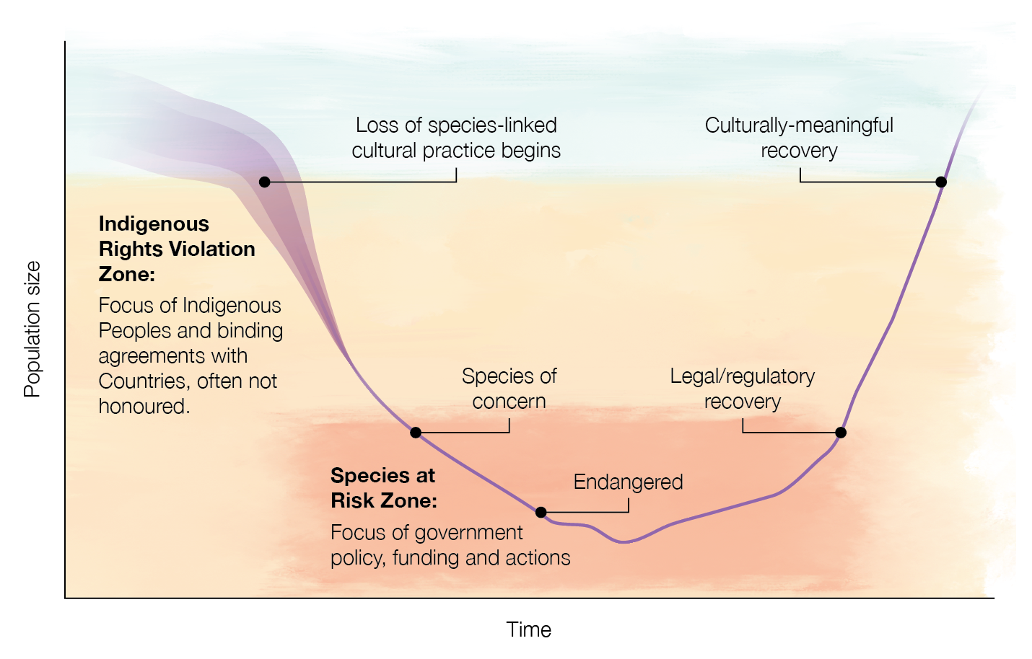

*Figure 1. Conceptual diagram of species abundance over time. Violation of Indigenous Rights occurs at a much higher abundance than the focus of current endangered species laws around achieving minimum viable populations.*

**Abstract**

Endangered species laws have successfully averted the extirpation of multiple species, but recovery to historic levels is rare. Endangered species laws are not designed to propel abundance beyond minimum viable populations, leaving many species extant, but in a state of diminished abundance. Sustaining culturally-important species—those species that disproportionately contribute to food, material, medicine, and spirituality—requires abundance that often far exceeds minimum viable population targets. Using three keystone species in North America—caribou, bison, and salmon—we contrast current species recovery efforts under endangered species laws and culturally-meaningful recovery targets enshrined in legal agreements between Indigenous peoples and countries. Given that species conservation ultimately relates to human values of biodiversity, nature, and a responsibility to all relations, it is imperative to incorporate these relationships in species recovery targets.

**One Sentence Summary:** Indigenous Rights can pick up where endangered species laws fall short in recovering species to culturally-meaningful levels.

**Main Text**

International treaties (e.g., the Convention on Biological Diversity) have supported initiation of national and continental legislation (e.g., United States (USA) Endangered Species Act [ESA], Canada’s Species at Risk Act [SARA], European Union Habitats Directive) that provide a powerful mechanism to formalize the conservation of nature. Endangered species laws guide recovery efforts for imperilled species and their ecosystems. Recovery efforts tend to focus on rare and charismatic species, with notable successes including the recovery of peregrine falcons (*Falco peregrinus*), bald eagles (*Haliaeetus leucocephalus*), and gray wolves (*Canis lupus*) in North America. Despite endangered species legislation, many species continue to decline and remain at abundances far lower than historical baselines [(*1*)](https://www.zotero.org/google-docs/?b6XqHO). Missing from endangered species laws are recovery targets and processes that can meaningfully recover culturally–important species—those species that disproportionately contribute to food, material, medicine, and spirituality.

Under endangered species laws in North America, recovery targets are left vague or are based on a minimum viable population (MVP) size [(*2*)](https://www.zotero.org/google-docs/?5L5DzU). In Canada, SARA focuses on risks of extinction and does not explicitly define recovery, although a 2020 SARA policy document interprets recovery in terms of reducing the risk of extinction or extirpation [(*3*)](https://www.zotero.org/google-docs/?PWv1xB). In the US, the focus is more on MVP –a number that Western scientists believe will enable population persistence with minimal human intervention. Risk-based and MVP-based recovery targets have set low ambitions in North America, simply aiming to maintain current population levels in the majority of recovery documents [(*4*)](https://www.zotero.org/google-docs/?1kZaBQ) and neither address how people, specifically Indigenous peoples, interact with the species through harvest. While harvest reflects time–honoured relationships to support food security, ceremonial practices, or other hallmarks of culture [(*5*)](https://www.zotero.org/google-docs/?RLxcHb), harvested species are systematically excluded from Canada’s listing process [(*6*)](https://www.zotero.org/google-docs/?urGFrR). A culturally–meaningful recovery target may require a larger abundance or different distribution than those prescribed by an MVP–based approach alone. Culturally–meaningful recovery also requires more inclusive policies to center Indigenous perspectives and peoples in the design and implementation of restorative actions [(*7*–*9*)](https://www.zotero.org/google-docs/?jgVEzh).

Here we describe three recovery efforts that demonstrate continued inequities in biodiversity conservation policies and highlight the need to reconsider recovery targets for culturally–important species in National policies. We focus on three high-profile species in North America—caribou, bison, and salmon—which have formed central aspects of Indigenous peoples’ diet, culture, and seasonal movements since time immemorial. In each case, the decline of these species impeded Indigenous peoples from carrying out cultural practices. Each species has since shown some level of recovery and we highlight how these recoveries—often considered conservation victories—remain distant from culturally–meaningful levels of recovery. This mismatch is partly due to a lack of formal legislation supporting culturally–meaningful recovery targets (Figure 1, Appendix 1).

*Caribou*—Woodland caribou (*Rangifer tarandus)* have long been a primary food source for northern Indigenous peoples in North America. Caribou have declined dramatically in the last century (Figure 2), especially in the southern portion of their range. Ten of 38 southern mountain caribou subpopulations are extirpated, and the species has declined by over 40% during the last 20 years as observed using Western monitoring techniques [(*7*)](https://www.zotero.org/google-docs/?BurZKx). But Indigenous Knowledge provides an invaluable historical baseline of abundance and harvest levels well before Western science was engaged in species recovery. For example, in British Columbia, Canada, Elders from the Treaty No. 8 adherent West Moberly First Nations Elders said the Klinse-Za caribou subpopulation was once as abundant as “*bugs on the landscape*”, yet by 2013 there were only 38 animals left [(*7*)](https://www.zotero.org/google-docs/?0NsjKA). Facing a decline in caribou, West Moberly leadership/Elders imposed a moratorium on caribou harvest in 1970 that is still in effect today. Indeed, West Moberly First Nations sensed the endangerment of caribou well before colonial governments, who permitted extensive natural resource extraction in the heart of Klinse-za caribou habitat for at least 50 years following West Moberly’s cessation of hunting. Continued authorization of resource development is likely an example of infringement of constitutionally protected Indigenous Rights to sustain a culturally meaningful way of life [(*10*)](https://www.zotero.org/google-docs/?2Ef2er).

Indigenous-led recovery efforts by West Moberly First Nations and Saulteau First Nations to recover the threatened Klinse-Za caribou have more than tripled caribou abundance in eight years [(*7*)](https://www.zotero.org/google-docs/?LV3j5M). Averting the looming extirpation of this caribou population is an undeniable conservation success, yet their abundance remains below a level where First Nations can participate in a culturally–meaningful harvest. In 2022, there were 114 Klinse-Za caribou – an abundance that met a recovery target of >100 set by the Canadian government under the MVP–based approach. However, 114 caribou would provide only ~3 caribou for a sustainable Indigenous harvest—not meeting historical levels of use by the community. A West Moberly Elders’ wish was to “*eat caribou before I die*”, which could be translated to a baseline cultural recovery target. If caribou are to be meaningfully harvested again there should be enough for each community member to have some significant level of food security met by caribou. For example, providing just one meal for each of the 1600 West Moberly and Saulteau First Nations members would require approximately 3 caribou, which could be sustainably harvested from a population of about 200 caribou. Providing 15 meals each would require a population of about 3000 caribou—more reflective of the historic “*bugs on the landscape*” abundance. The discrepancy between the current 114 caribou and the potential 3000 caribou is a measurable gap in Western and Indigenous perspectives on recovery and reconciliation.

*American bison*—Prior to colonization, American bison (*Bison bison*) numbered 30–60 million across North America [(*8*)](https://www.zotero.org/google-docs/?GW2HdI). Many Indigenous peoples were deeply dependent upon these once-abundant bison populations that ranged from Alaska to Mexico (Figure 2). By the turn of the 20th century, however, the great bison herds had been slaughtered down to only a few hundred animals, in part driven by explicit policies of cultural genocide. Such dramatic bison declines caused starvation, in-fighting, and erosion of Indigenous ways of being [(*11*)](https://www.zotero.org/google-docs/?z28PHD).

The northern subspecies of American bison, wood bison (*Bison bison athabascae*) were listed as endangered under the ESA in 1979 and classified as endangered in Canada by COSEWIC in 1978 (pre-dating SARA). Recovery actions included establishing new wood bison populations and abundance to nearly 10,000 in 2013. As a result, COSEWIC downlisted them to Threatened, with *at least* 5 free-ranging populations of 1,000 bison as the MVP goal. Despite this example of MVP recovery, Indigenous peoples are often still prevented from harvesting them, for example, in Canada’s Wood Buffalo National Park. Thus, wood bison recovery highlights the continued mismatch between MVP recovery and culturally–meaningful recovery of wood bison.

The precipitous decline of the southern subspecies, plains bison (*Bison bison bison),* occurred well before the endangered species laws of Canada (2002) or the United States of America (1973) came into effect. Nevertheless, wild plains bison are still clearly endangered. Today, the species remains at <1% of its historic abundance and occupies a dramatically reduced range (Figure 2). Despite early recovery efforts, wild free-ranging plains bison populations represent only 10% of the current abundance of plains bison, the remaining 90% are privately owned [(*8*)](https://www.zotero.org/google-docs/?CLgsCN). Yet, plains bison remain unlisted in either country despite clear recommendations to do so.

Recently, an inspiring example of Indigenous leadership in plains bison restoration began unfolding. On September 23, 2014, thirteen First Nations and Native American tribes signed the first intertribal Treaty in 150 years—the Buffalo Treaty— focused on ecological and cultural recovery of plains bison [(*8*)](https://www.zotero.org/google-docs/?LTJSVs). Supported in part by the Buffalo Treaty, Banff National Park, Canada, initiated a plains bison restoration program in 2017. The long-term reintroduction goal in Banff is to include culturally meaningful co-management of bison harvest with Buffalo Treaty signatories. The contemporary successes of bison restoration have increased the likelihood of bison recovery under MVP criteria. But bison recovery will remain incomplete until peoples’ connection—including a key role in diet—with bison is restored across broader landscapes (*9*).

*Pacific salmon*—Millions of salmon (*Oncorhynchus* spp.) annually return to rivers across western North America (Figure 2), providing sustenance for people, wildlife, and ecosystems. Indigenous peoples in the Pacific Northwest often refer to themselves as “salmon people'', signifying their deeply rooted cultural connections with salmon [(*9*)](https://www.zotero.org/google-docs/?UgtmI7).

The distribution and abundance of salmon have decreased over the last century through the effects of human activities (Figure 2). In the Columbia Basin, USA, salmon abundance has declined by ~75%; an estimated 7.5–16 million salmon returned annually to the Columbia prior to the 20th century, and now only 1–4 million return (Figure 2)[(*12*)](https://www.zotero.org/google-docs/?NJLmWR). The most commercially–valuable and culturally–important salmon species in Canada, sockeye (*O. nerka*), declined in wild abundance and diversity by ~70% over the last century in the country’s second-largest salmon watershed [(*13*)](https://www.zotero.org/google-docs/?uix5CV). Salmon harvests by Indigenous communities in Canada have declined by over 80% in the last 50–70 years *(4)*, with some First Nations having imposed harvest bans [(*13*)](https://www.zotero.org/google-docs/?6x73L2).

Salmon recovery is demonstrably underserved by endangered species legislation. No salmon population has been listed in Canada under SARA and while some have in the USA, abundance remains a fraction of historic levels. Given the lack of formal protection, several Indigenous-led recovery plans for salmon have recently been developed. For example, after having endured ~60 years of diminished sockeye salmon returns, the Wet’suwet’en Nation have implemented a rebuilding plan with an abundance target set to provide for community and ecosystem needs. However, ongoing commercial fisheries and industrial development projects undermine salmon recovery efforts; thus, there remains a need for increased recognition of Indigenous Rights that support protection of diminished populations beyond endangered species legislation.

*Indigenous rights can propel recovery beyond targets set by endangered species laws*

While international agreements and national laws compel governments to recover endangered species, governments are also obligated to fulfill treaty and constitutional rights to Indigenous people. In some cases, culturally–important species are at the center of the interaction between Indigenous and non-Indigenous governments. For example, during negotiations of Treaty No. 8 in 1899, Canada promised Indigenous peoples in Treaty 8, which encompasses nearly 10% of Canada, that they “*would be as free to hunt and fish after treaty as they would if they never entered into it*” [(*14*)](https://www.zotero.org/google-docs/?VwYgx7). A century and a half of colonization on these lands have significantly impeded Treaty 8 First Nations’ ability to hunt and fish as they once did [(*10*)](https://www.zotero.org/google-docs/?ENSAmD). Treaty infringement was recently affirmed in the 2021 Blueberry River First Nations (Yahey) **v**. Province of British Columbia, which concluded that the Province had breached Treaty No. 8 by authorizing rampant resource development, leading to cumulative impacts, affecting culturally–important species such as caribou and moose.

Increased recognition of legal obligations to Indigenous peoples may provide the path to recovering species abundance to culturally–meaningful levels. Recovery plans for culturally–important species should pose MVP targets as only the first step in recovery. For species above a MVP, recovery status could be assessed against a new global standard, the International Union for Conservation of Nature (IUCN) Green list of species, to propel abundance beyond MVP towards `full recovery` defined by restoring historic abundance, distribution, and ecological function [(*1*)](https://www.zotero.org/google-docs/?o4AX8w). We recommend `full recovery` should additionally include abundance targets that support food security, materials, and relationships that rely on these animals. A rare example of this already occurring can be found in the 2016 wood bison recovery strategy that includes abundance targets to support Indigenous Rights and particularly a culturally-meaningful harvest. Beyond legally endangered species, a proactive approach to conservation would consider species not yet at the precipice of extirpation, but below culturally–meaningful abundance thresholds; thus, triggering mechanisms of recovery based on protection of Indigenous Rights (Figure 1).

Harmonization of biodiversity agreements with international agreements such as the United Nations Declaration on the Rights of Indigenous Peoples (UNDRIP) could provide the foundation for recultivating available, accessible, and adequate food, with strong nutritional, cultural, and spiritual connections to a single species or entire ecosystem [(*15*)](https://www.zotero.org/google-docs/?JrjLF0). Given the fundamental reason for conserving species relates to human values of biodiversity, nature, and a responsibility to all relations, restoring the very connections that propel recovery will serve to make efforts more successful while protecting critical relationships between people and the Land.

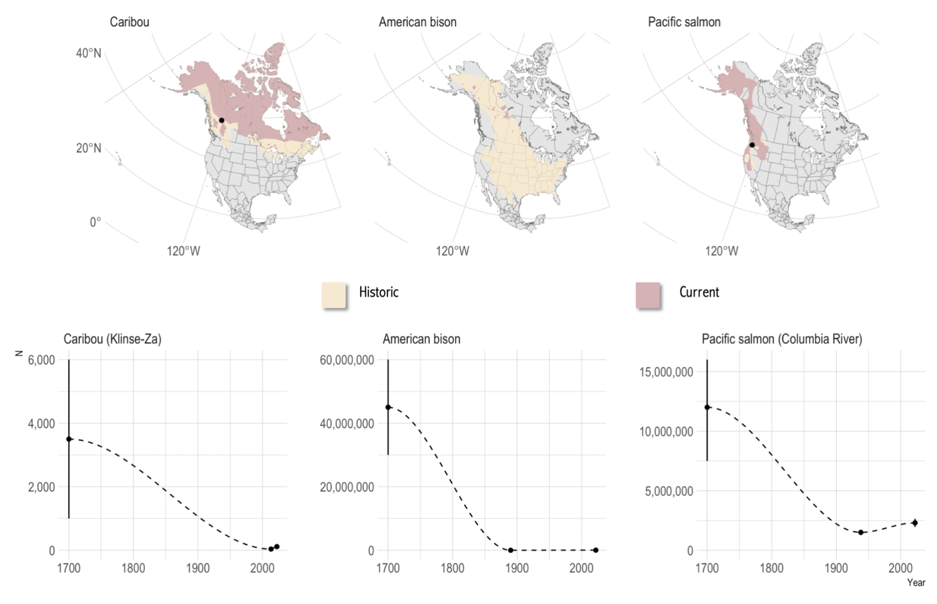

*Figure 2. Examples of culturally-important species across North America whose abundance does not meet culturally meaningful levels. Top shows historic (tan) and current (purple) distributions for woodland caribou, American bison, and Pacific salmon. The bottom shows the abundance trajectory for the species, or a focal population with sufficient data to characterize a broader regional trend (shown as a dot on the map above). Estimated abundance prior to colonization and large-scale industrial impacts shown at year 1700. Lowest recorded population estimate post-colonization is shown between 1900-2013, and the most current estimate is shown. Klinse-Za pre-colonization abundance translated from Indigenous Knowledge of a “sea of caribou” to ~1500-6000 caribou. See appendix 2 for data and citations.*

**References and Notes:**

[1. M. K. Grace, H. R. Akçakaya, E. L. Bennett, T. M. Brooks, A. Heath, S. Hedges, C. Hilton‐Taylor, M. Hoffmann, A. Hochkirch, R. Jenkins, D. A. Keith, B. Long, D. P. Mallon, E. Meijaard, E. J. Milner‐Gulland, J. P. Rodriguez, P. J. Stephenson, S. N. Stuart, R. P. Young, P. Acebes, J. Alfaro‐Shigueto, S. Alvarez‐Clare, R. R. Andriantsimanarilafy, M. Arbetman, C. Azat, G. Bacchetta, R. Badola, L. M. D. Barcelos, J. P. Barreiros, S. Basak, D. J. Berger, S. Bhattacharyya, G. Bino, P. A. V. Borges, R. K. Boughton, H. J. Brockmann, H. L. Buckley, I. J. Burfield, J. Burton, T. Camacho‐Badani, L. S. Cano‐Alonso, R. H. Carmichael, C. Carrero, J. P. Carroll, G. Catsadorakis, D. G. Chapple, G. Chapron, G. W. Chowdhury, L. Claassens, D. Cogoni, R. Constantine, C. A. Craig, A. A. Cunningham, N. Dahal, J. C. Daltry, G. C. Das, N. Dasgupta, A. Davey, K. Davies, P. Develey, V. Elangovan, D. Fairclough, M. D. Febbraro, G. Fenu, F. M. Fernandes, E. P. Fernandez, B. Finucci, R. Földesi, C. M. Foley, M. Ford, M. R. J. Forstner, N. García, R. Garcia‐Sandoval, P. C. Gardner, R. Garibay‐Orijel, M. Gatan‐Balbas, I. Gauto, M. G. U. Ghazi, S. S. Godfrey, M. Gollock, B. A. González, T. D. Grant, T. Gray, A. J. Gregory, R. H. A. van Grunsven, M. Gryzenhout, N. C. Guernsey, G. Gupta, C. Hagen, C. A. Hagen, M. B. Hall, E. Hallerman, K. Hare, T. Hart, R. Hartdegen, Y. Harvey‐Brown, R. Hatfield, T. Hawke, C. Hermes, R. Hitchmough, P. M. Hoffmann, C. Howarth, M. A. Hudson, S. A. Hussain, C. Huveneers, H. Jacques, D. Jorgensen, S. Katdare, L. K. D. Katsis, R. Kaul, B. Kaunda‐Arara, L. Keith‐Diagne, D. T. Kraus, T. M. de Lima, K. Lindeman, J. Linsky, E. Louis, A. Loy, E. N. Lughadha, J. C. Mangel, P. E. Marinari, G. M. Martin, G. Martinelli, P. J. K. McGowan, A. McInnes, E. Teles Barbosa Mendes, M. J. Millard, C. Mirande, D. Money, J. M. Monks, C. L. Morales, N. N. Mumu, R. Negrao, A. H. Nguyen, Md. N. H. Niloy, G. L. Norbury, C. Nordmeyer, D. Norris, M. O’Brien, G. A. Oda, S. Orsenigo, M. E. Outerbridge, S. Pasachnik, J. C. Pérez‐Jiménez, C. Pike, F. Pilkington, G. Plumb, R. de C. Q. Portela, A. Prohaska, M. G. Quintana, E. F. Rakotondrasoa, D. H. Ranglack, H. Rankou, A. P. Rawat, J. T. Reardon, M. L. Rheingantz, S. C. Richter, M. C. Rivers, L. R. Rogers, P. da Rosa, P. Rose, E. Royer, C. Ryan, Y. J. S. de Mitcheson, L. Salmon, C. H. Salvador, M. J. Samways, T. Sanjuan, A. Souza dos Santos, H. Sasaki, E. Schutz, H. A. Scott, R. M. Scott, F. Serena, S. P. Sharma, J. A. Shuey, C. J. P. Silva, J. P. Simaika, D. R. Smith, J. L. Y. Spaet, S. Sultana, B. K. Talukdar, V. Tatayah, P. Thomas, A. Tringali, H. Trinh‐Dinh, C. Tuboi, A. A. Usmani, A. M. Vasco‐Palacios, J. Vié, E. Virens, A. Walker, B. Wallace, L. J. Waller, H. Wang, O. R. Wearn, M. van Weerd, S. Weigmann, D. Willcox, J. Woinarski, J. W. H. Yong, S. Young, Testing a global standard for quantifying species recovery and assessing conservation impact. *Conservation Biology*. **35**, 1833–1849 (2021).](https://www.zotero.org/google-docs/?mzxOox)

[2. M. E. Soulé, *Viable Populations for Conservation* (Cambridge University Press, Cambridge University, 1987; https://www.cambridge.org/core/books/viable-populations-for-conservation/520CF6EB41B08407517E83FE3A427687).](https://www.zotero.org/google-docs/?mzxOox)

[3. ECCC, “Species at Risk Act Policies: Policy on Recovery and Survival” (Canada, 2020), p. 9.](https://www.zotero.org/google-docs/?mzxOox)

[4. K. A. Pawluk, C. H. Fox, C. N. Service, E. H. Stredulinsky, H. M. Bryan, Raising the bar: Recovery ambition for species at risk in Canada and the US. *PLoS ONE*. **14**, e0224021 (2019).](https://www.zotero.org/google-docs/?mzxOox)

[5. P. Priadka, B. Moses, C. Kozmik, S. Kell, J. N. Popp, Impacts of harvested species declines on Indigenous Peoples’ food sovereignty, well-being and ways of life: a case study of Anishinaabe perspectives and moose. *E&S*. **27**, art30 (2022).](https://www.zotero.org/google-docs/?mzxOox)

[6. C. S. Findlay, S. Elgie, B. Giles, L. Burr, Species Listing under Canada’s Species at Risk Act. *Conservation Biology*. **23**, 1609–1617 (2009).](https://www.zotero.org/google-docs/?mzxOox)

[7. C. T. Lamb, R. Willson, C. Richter, N. Owens-Beek, J. Napoleon, B. Muir, S. McNay, E. Lavis, M. Hebblewhite, L. Giguere, T. Dokkie, S. Boutin, A. T. Ford, Indigenous-led conservation: pathways to recovery for the nearly extirpated Klinse- Za mountain caribou. *Ecological Applications* (2022).](https://www.zotero.org/google-docs/?mzxOox)

[8. H. Shamon, O. G. Cosby, C. L. Andersen, H. Augare, J. BearCub Stiffarm, C. E. Bresnan, B. L. Brock, E. Carlson, J. L. Deichmann, A. Epps, N. Guernsey, C. Hartway, D. Jørgensen, W. Kipp, D. Kinsey, K. J. Komatsu, K. Kunkel, R. Magnan, J. M. Martin, B. D. Maxwell, W. J. McShea, C. Mormorunni, S. Olimb, M. Rattling Hawk, R. Ready, R. Smith, M. Songer, B. Speakthunder, G. Stafne, M. Weatherwax, T. S. Akre, The Potential of Bison Restoration as an Ecological Approach to Future Tribal Food Sovereignty on the Northern Great Plains. *Frontiers in Ecology and Evolution*. **10** (2022) (available at https://www.frontiersin.org/article/10.3389/fevo.2022.826282).](https://www.zotero.org/google-docs/?mzxOox)

[9. A. J. Reid, N. Young, S. G. Hinch, S. J. Cooke, Learning from Indigenous knowledge holders on the state and future of wild Pacific salmon. *FACETS*. **7**, 718–740 (2022).](https://www.zotero.org/google-docs/?mzxOox)

[10. B. R. Muir, A. L. Booth, An environmental justice analysis of caribou recovery planning, protection of an Indigenous culture, and coal mining development in northeast British Columbia, Canada. *Environ Dev Sustain*. **14**, 455–476 (2012).](https://www.zotero.org/google-docs/?mzxOox)

[11. J. Daschuk, *Clearing the plains: disease, politics of starvation, and the loss of indigenous life* (2019; https://uofrpress.ca/Books/C/Clearing-the-Plains).](https://www.zotero.org/google-docs/?mzxOox)

[12. C. L. Smith, “Salmon Abundance and Diversity in Oregon Are We Making Progress?” (M/A-21, Oregon State University, Oregon, USA, 2014), p. 16.](https://www.zotero.org/google-docs/?mzxOox)

[13. M. H. H. Price, J. W. Moore, B. M. Connors, K. L. Wilson, J. D. Reynolds, Portfolio simplification arising from a century of change in salmon population diversity and artificial production. *J Appl Ecol*. **58**, 1477–1486 (2021).](https://www.zotero.org/google-docs/?mzxOox)

[14. Government of Canada, “Report of the Commissioners for Treaty No. 8.” (agreement, 1899), (available at https://www.rcaanc-cirnac.gc.ca/eng/1100100028813/1581293624572).](https://www.zotero.org/google-docs/?mzxOox)

[15. M. A. Hessami, E. Bowles, J. N. Popp, A. T. Ford, Indigenizing the North American Model of Wildlife Conservation. *FACETS*. **6**, 1285–1306 (2021).](https://www.zotero.org/google-docs/?mzxOox)

**Acknowledgments:** We would like to thank the Mitacs Accelerate program, Nîkanêse Wah tzee Stewardship Society, and the Canadian Mountain Network for supporting this work. This work benefited from review by Mr. Joshua Lam of Sage Legal, Mr. Martin Olyszynski at the University of Calgary’s Faculty of Law.

**Supplementary Materials:**

Supplementary Material 1**:** Examples of discrepancies between endangered species laws or criteria and culturally-meaningful recovery

Supplementary Material 2: Data and citations for Fig 2.

**Figure legends**

*Figure 1. Conceptual diagram of species abundance over time. Violation of Indigenous Rights occurs at a much higher abundance than the focus of current endangered species laws around achieving minimum viable populations.*

*Figure 2. Examples of culturally-important species across North America whose abundance does not meet culturally meaningful levels. Top shows historic (tan) and current (purple) distributions for woodland caribou, American bison, and Pacific salmon. The bottom shows the abundance trajectory for the species, or a focal population with sufficient data to characterize a broader regional trend (shown as a dot on the map above). Estimated abundance prior to colonization and large-scale industrial impacts shown at year 1700. Lowest recorded population estimate post-colonization is shown between 1900-2013, and the most current estimate is shown. Klinse-Za pre-colonization abundance translated from Indigenous Knowledge of a “sea of caribou” to ~1500-6000 caribou. See appendix 2 for data and citations.*